FOR IMMEDIATE RELEASE

Austin Fermentation Festival, October 25th, 2015, Austin, TX
Keynote Speaker: Jennifer McGruther of Nourished Kitchen

October 25, 2015 (AUSTIN, TX) – Texas Farmers’ Market and Presenting Sponsor Barr Mansion announce the 2015 Austin Fermentation Festival with keynote speaker, blogger, author, and traditional foods advocate Jennifer McGruther.

The Austin Fermentation Festival is an educational event that celebrates all things fermented in Central Texas and will run from 9am – 4pm at Barr Mansion (10463 Sprinkle Road, Austin, TX 78754). Proceeds from this event will benefit the Texas Farmers’ Market Farmer Emergency Fund, which offers financial assistance to TFM farmers and ranchers in times of environmental, personal or other crisis.

The day will include a series of fermentation workshops (covering topics such as kimchi, kefir, cheese making, charcuterie, beer, sourdough, vinegars and lacto-fermented vegetables); a community culture swap; a kraut mob; fermented foods and product vendors; book sales; festival-inspired lunch for purchase from local purveyors; fermented beverages and alcohol; a mini farmers’ market; and live music.

Attend by securing general admission or VIP tickets at http://fermentatx2015.eventbrite.com, where online donations to this fundraiser event are also accepted.
Vendor applications are accepted here bit.ly/AFFVendorApplication2015 and workshop presenter applications accepted here bit.ly/AFFWorkshopApplication2015.

Special thanks to Media Sponsor Edible Austin, Community Sponsor Whole Foods Market, Tent Sponsor Whim Event Rentals and Business Sponsor Austin Food & Wine Alliance. Business sponsor opportunities still available.

Share information about the Austin Fermentation Festival with the hashtag #fermentatx #austinfermentationfestival2015. For more information, please visit http://texasfarmersmarket.org/austin-fermentation-festival/.
# # #
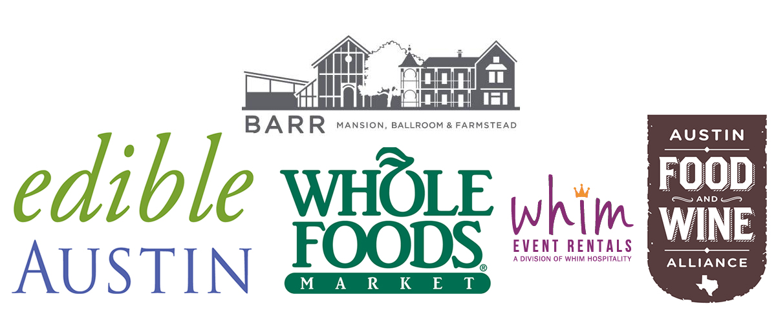
TEXAS FARMERS’ MARKET operates farmers' markets at Lakeline, Mueller and the Domain, which are year-round, rain-or-shine, producer only markets. TFM at Lakeline runs every Saturday from 9a-1p in the Lakeline Mall parking lot (between Sears and Dillards). TFM at Mueller runs every Sunday from 9a-1p under the Browning Hangar or lakeside next to Mueller Central. TFM at Domain runs every Sunday from 3-6p surrounding the lawn area in front of the iPic Theater in the Domain.

Texas Farmers’ Market is organized under F2M Texas, a 501(c)4 non-profit corporation that provides Central Texas farmers and ranchers beneficial, direct-marketing opportunities and provides Central Texans a wide variety of locally-produced foods in convenient locations. F2M Texas also educates the public about nutritional, economic, environmental, and social implications of eating seasonally and locally.

For more information find us on Facebook and visit http://texasfarmersmarket.org/.

Twitter: @TFMLakeline @TFMMueller @TFMDomain
Instagram: @texasfarmersmarket

